NAME:VENKATRAMAMOORTHY.G
- Print numbers 1 to 10 using for loop.
A for loop is used when you know how many times you want to repeat something.
It has three parts:
Start value (let i = 1) ,Condition (i <= 10) ,Update (i++)
CODE:
for(let i=1;i<=10;i++){
console.log(i);
}
OUTPUT:
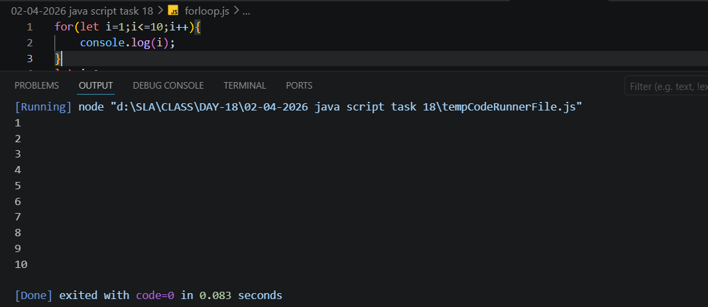
- Print numbers 1 to 5 using while loop.
A while loop runs as long as the condition is true.
CODE:
let i=1;
while(i<=5){
console.log(i);
i++;
}
OUTPUT:
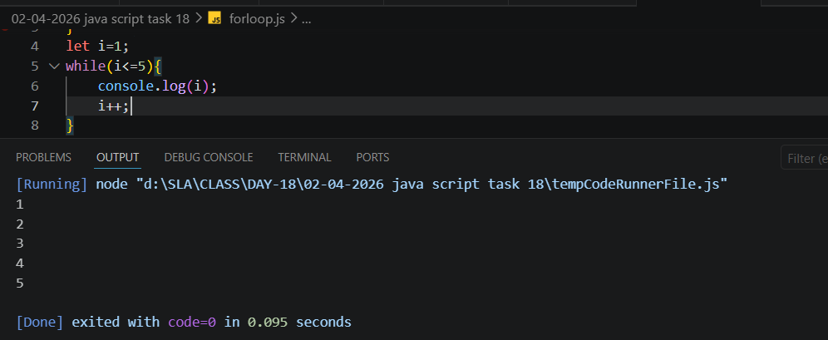
- Print numbers 1 to 3 using do-while loop.
A do-while loop runs the code first, then checks the condition.
CODE:
let a=1;
do{
console.log(a);
a++;
}
while(a<=3);
OUTPUT:
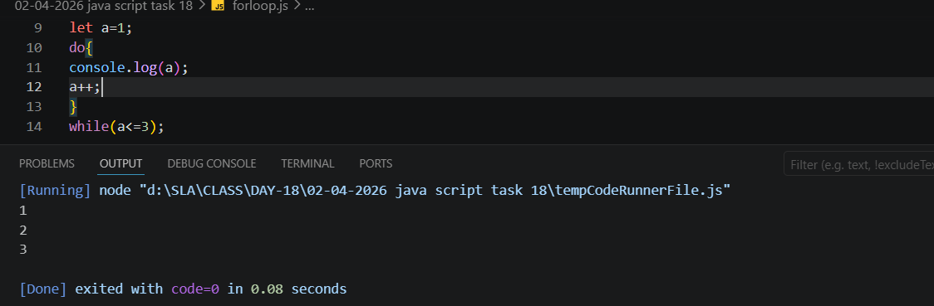
- Print numbers 1–10, skip 5 using continue, stop at 8 using break.
The break statement is used to stop the loop immediately.
The continue statement skips the current step and moves to the next loop iteration.
CODE:
for(let j=1;j<=10;j++){
if(j===5){
continue;
}
else if(j===8){
break;
}
else{
console.log(j);
}
}
OUTPUT:
